Advanced Computer Networks – PCS223
Assignment 6
Name – Writick Parui
Subgroup – CS4
Roll No. – 8025320111
Q.1 Objective
To configure and verify routing using RIP Version 2 protocol in a network.

Problem Statement
Design and implement the given network topology in Cisco Packet Tracer with three routers
(R1, R2, R3), two LANs, and PCs using the provided IP addressing scheme.
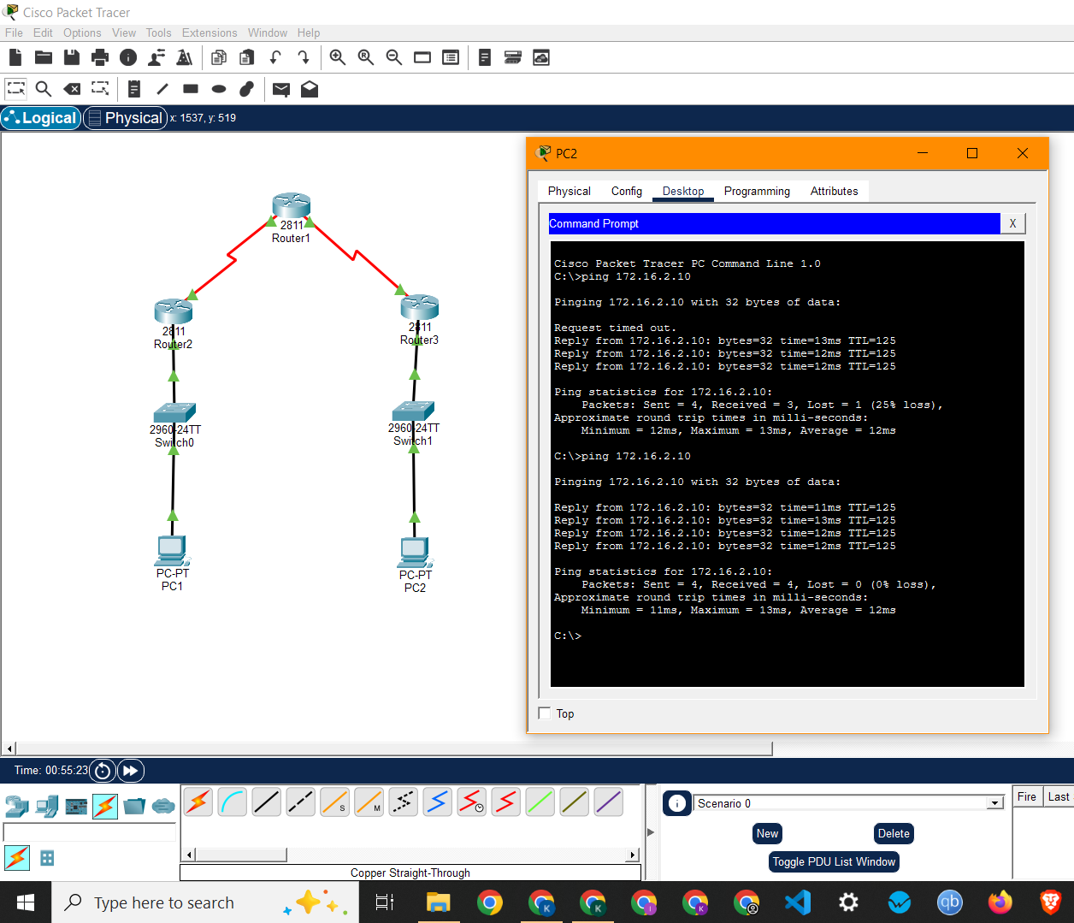
Screenshot showing network topology and successful ping from PC2 to PC1

